Effect of Electrostatic Tactile Feedback on Accuracy and Efficiency of Pan Gestures on Touch Screens

【Summary】：

1. A custom-designed electrostatic tactile display was used to explore the variations in accuracy and efﬁ-ciency under two conditions as to whether electro-static tactile feedback is utilized on a touch screen. The experimental results with twelve participants illustrate that the accuracy and completion time (CT) of pan gestures with the added tactile feedback signiﬁcantly exceed those without tactile feedback.
2. The added electrostatic tactile feedback was used to explore the manner in which the completion time (CT) of pan gestures evolves with different indices of difﬁculties (ID). The experimental results indicate that the relationship between CT and ID satisﬁes Fitts’ Law, and the related correlation coefﬁcient is higher than 0.9.
3. A “Tactile Fruit Sorting” game was designed to illus-trate the beneﬁts of tactile-enhanced pan gestures. Both subjective and objective evaluations indicate that the added electrostatic tactile feedback improves players’ performance and enhances users’ interest in the game.

【3 methods of haptic feedback】:

Haptic feedback-mechanical movement can not produce a fine and detailed touch

Haptic feedback-piezoelectric vibration Low friction level

Haptic feedback-electrostatic tactile feedback Higher friction levels

【electrostatic screen principal】:

A Coulomb force is produced between ﬁngers and the sur-face while sliding ﬁngers on conductive surface covered with a thin insulating layer. Fingers and the surface are considered as two plates of the capacity, and the alternat-ing voltage is loaded to the surface to produce the electro-static attraction force.

【Experiments】：

Apparatus：

a Microsoft Surface, a Micro-touch screen, a tactile controlling module, and a ﬁnger tracking module

In a manner similar to Tesla Touch [4], [27], the electro-static tactile display shown in Fig. 2 displays detailed shapes and textures of images presented on the screen. Additionally, different friction patterns are produced by generating different stimuli signals including sinusoidal and square waves [28], [29].

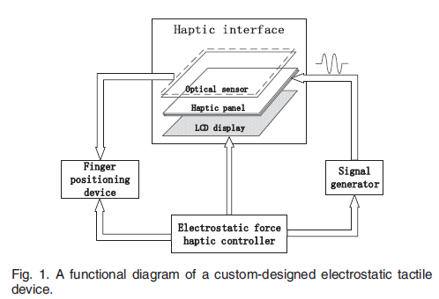 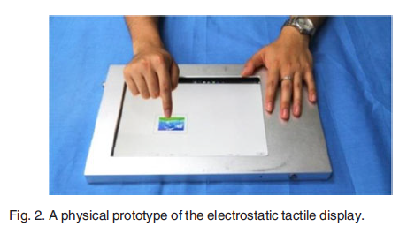

Design:

**E1: Efﬁciency Analysis with Electrostatic Tactile Feedback** (Evaluation of haptic feedback effectiveness)

The goal of this part involves com-paring the efﬁciency of pan gestures with and without elec-trostatic tactile feedback. The efﬁciency is evaluated by the completion time (CT) of moving a picture from an initial position to a target position, while the two positions are deﬁned with a ﬁxed distance A, an allowable error W, size, and the coordinates of centers.

(A is defined as the distance between the center of the original region and the center of the target region. In addition, W is defined as the maximum allowable error between the center of the target region and the center of the final position of the moving image.)

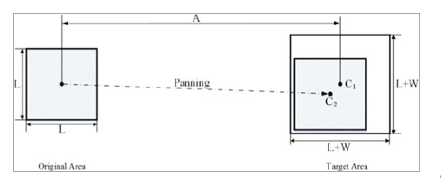

Procedure：

In the formal experiments, each participant participated in two groups of experiments. In group 1: only visual infor-mation was provided, and in group 2: both tactile informa-tion and visual information were provided. Half of the participants ﬁrst participated in the experiments termed as group 1, and subsequently participated in the other group of experiments, conversely, the other half of the participants participated in two groups of experiments in the opposite order to avoid “the practicing effect”. In both groups, each participant moved the image from the initial area to the tar-get area and repeated the same ten times. Each participant had two minutes between repetitive experiments to rest, and the time taken by the participants to complete the experi-ments approximately corresponded to sixteen minutes.

The completion time of the pan gesture is calculated as: t1 and t2 represent the moment when the participant's finger touched and raised the image:Image

Results：

1. The error rates with and without feedback are: 0.833% and 1.667%

(2) All participants who received electrostatic tactile feedback spent a short time moving the image to the target area

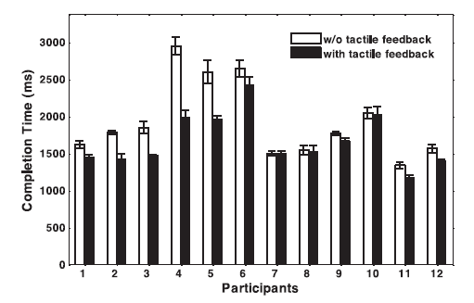

Discuss：

The friction force is typically very small for a smooth screen surface composed of glass material. While panning a picture with a high sliding speed on this type of a screen sur-face, the inertia effect causes the picture to be moved to a fur-ther area as opposed to the target area [30].

**E2: THE RELATIONSHIP BETWEEN COMPLETION TIME AND INDEX OF DIFFICULTIES** (Relationship between completion time and difficulty)

Two independent variables: distance A between the center of the original image position and the center of the target area A / maximum error

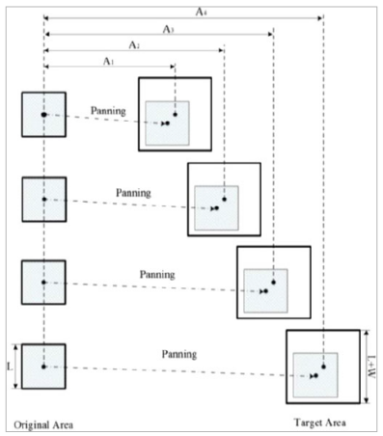 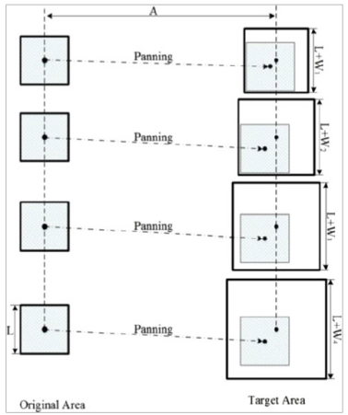

Results：

It can be seen from the figure that the completion difficulty becomes longer as the difficulty coefficient increases.

In order to determine the relationship between completion time (CT ) and the other two independent variables A and W, Fitts’ Law is utilized to analyze the recorded data.

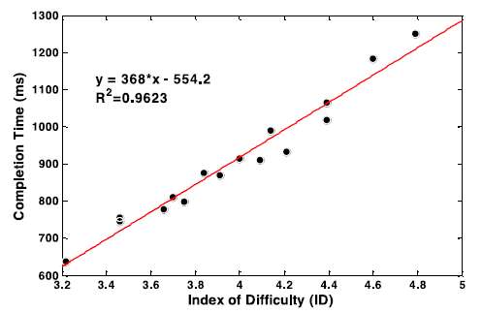

**E3: “TACTILE FRUIT SORTING” GAME**

Procedure：

In order to evaluate the efﬁciency of this game, the twelve participants were invited to play the game under the follow-ing two conditions: with and without electrostatic tactile feedback. Each participant conducted ten sessions for each condition. All participants were randomly divided into two groups with an equal number of participants in each group. The ﬁrst group ﬁrst played ten sessions under the condition without tactile feedback, and then played ten sessions with tactile feedback. The second group played this game under two conditions in a reversed order.

Results：

Both subjective and objective evaluations indicate that increased haptic feedback can improve player performance and increase user interest in the game.

The underlying cause of this phenomenon is that the linear friction force reduces the inertia effect of sliding fingers, thereby achieving accurate and fast positioning on the touch screen.

Continuous electrostatic haptic feedback helps to maintain a compromise between moving speed and accuracy, so it's easier for participants to quickly drag fruit to the corresponding target area.

【Important Reference】:

[1] M. Minsky, M. Ouh-young, O. Steele, F. P. Brooks, and M. Behensky, “Feeling and seeing: issues in force display,” ACM SIGGRAPH Comput. Graph., vol. 24, no. 2, pp. 235–241, 1990.

[2] S. Saga and K. Deguchi, “Lateral-force-based 2.5-dimensional tac-tile display for touch screen,” in Proc. IEEE Haptics Symp., 2012, pp. 15–22.

[3] S. Saga and K. Deguchi, “Lateral-force-based 2.5-dimensional tac-tile display for touch screen,” in Proc. IEEE Haptics Symp., 2012, pp. 15–22.

[6] V. Hayward and M. Cruz-Hernandez, “Tactile display device using distributed lateral skin stretch,” in Proc Haptic Interfaces Virtual Envi-ron. Teleoperator Syst. Symp., 2000, vol. 69, no. 2, pp. 1309–1314.

[7] C. R. Wagner, S. J. Lederman, and R. D. Howe, “A tactile shape display using RC servomotors,” in Proc. Haptic Interfaces Virtual Environ. Teleoperator Syst. Symp., 2002, pp. 354–354.

[8] K. Yatani and K. N. Truong, “SemFeel: A user interface with semantic tactile feedback for mobile touch-screen devices,” in Proc. 22nd Annual ACM Symp., 2009, pp. 111–120.

[9] G. H. Yang, M. Jin, and Y. Jin, “T-mobile: Vibrotactile display pad with spatial and directional information for hand-held device,” in Proc. IEEE/RSJ Int. Conf. Intell. Robots Syst., 2010, pp. 5245–5250.

[10] L. Winﬁeld, J. Glassmire, J. E. Colgate, and M. Peshkin, “T-pad: Tactile pattern display through variable friction reduction,” in Proc. Symp. Haptic Interfaces Virtual Environ. Teleoperator Syst., 2007, pp. 421–426.

[11] N. D. Marchuk, J. E. Colgate, and M. A. Peshkin, “Friction meas-urements on a Large Area TPaD,” in Proc. Haptics Symp., 2010, pp. 317–320.

[12] M. Amberg, F. Giraud, B. Semail, P. Olivo, G. Casiez, and N. Roussel, “STIMTAC: A tactile input device with programmable friction,” in Proc. 24th Annu. ACM Symp. Adjunct User Interface Softw. Technol., 2011, pp. 7–8.

[13] X. Dai, J. Gu, X. Cao, J. E. Colgate, and Z. T. Hong, “SlickFeel: Slid-ing and clicking haptic feedback on a touchscreen,” in Proc. 25th Annu. ACM Symp. User Interface Softw. Technol., pp. 21–22, 2012.

[14] A. Yamamoto, S. Nagasawa, and H. Yamamoto, “Electrostatic tac-tile display with thin ﬁlm slider and its application to the tactile telepresentation systems,” IEEE Trans. Vis. Comput. Graph., vol. 12, no. 2, pp. 168–177, Mar./Apr. 2006.

[15] O. Bau and I. Poupyrev, “REVEL: Tactile feedback technology for augmented reality,” ACM Trans. Graph., vol. 31, no. 4, pp. 13–15, 2012.

[27] O. Bau and L. Poupyrev, “A tactile feedback technology for aug-mented eality,” ACM Trans. Graphics, vol. 31, no. 4, pp. 13–15, 2012.